Credentials and Statement of Purpose

(Madhur Anand Gupta)

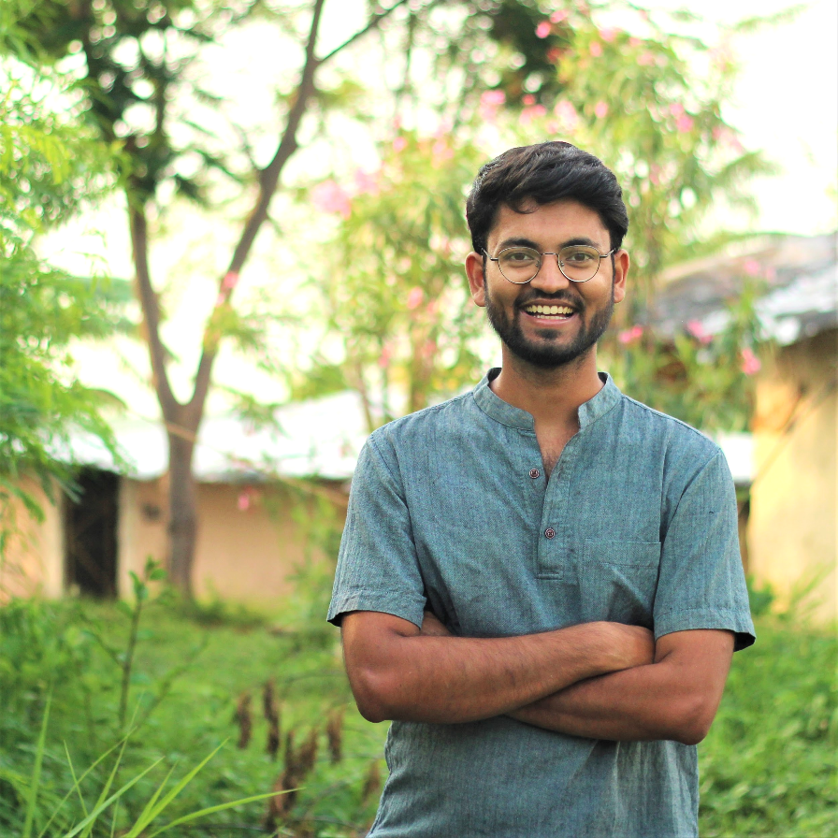

After completing my K-12 in 2012, I joined [Swaraj University](http://www.swarajuniversity.org/)’s 2 year long Khoji Program on Youth Leadership and Green Entrepreneurship. This experience fostered an attitude of self-directed learning, introduced me to an alternate vision of living and helped me figure out my interests. During this period, I also participated in a 13-episode TV show ‘[Green Champion](https://sites.ndtv.com/green-champion/contender-madhur-anand/)’ on NDTV and walked out as a semi-finalist. Thereafter, I spent some time in [storytelling](http://thekahaniproject.org/author/madhur/), film making and facilitating youth workshops on sustainability and creativity. Simultaneously, I took up technical employment with a research publishing company [Inventi Journals](http://www.inventi.in/).

In 2016, I co-founded a health space ‘[Sehatvan](https://sehatvan.in/)’ with my health-scientist father. We derived its name by combining an Urdu word ‘*sehat*’ meaning health with ‘*van*’, a hindi word meaning ‘forest’. Over the last few years, living and experimenting in this space, we realized community living, wilderness and fasting have profound effects on health restoration. Our approach is guided by the Hindi word for healthy - ‘*swasth*’. *Swasth* is formed by combining two separate words ‘*swa* + *sthit*’, which mean ‘being situated in oneself’. Hence, the emotional dimension of well being/fitness has been an important element in health restoration at *Sehatvan*. And it is from this understanding, that I developed a deeper interest in psychology that led to my pursuing a bachelor’s and master’s in this field.

At this juncture, I have a deep quest to understand the interconnectedness of wilderness, emotional fitness and homeostasis. To pursue this, I am working on a project ‘Mood Forest’ on one hand, and on the other hand, attempting to join a doctoral program which can facilitate this kind of research. I’m curating my broad research interest on this site - <https://moodforest.co>

By now, *Sehatvan* is a reasonably well appreciated phenomenon. Its [YouTube channel](https://www.youtube.com/sehatvan) and [Facebook](https://www.facebook.com/Sehatvan) and [Instagram](https://www.instagram.com/sehatvan/?hl=en) pages have decent followings and ratings with some of the videos having received [millions of views](https://www.facebook.com/watch/?v=1536754883070840). We have also been able to attract mainstream media attention: India’s national broadcaster ‘Doordarshan’ featured *Sehatvan* in its documentary [India’s Healing Forests](https://www.youtube.com/watch?v=94Swm13p4bA); country’s leading Hindi daily Dainik Bhaskar published a [story](https://www.bhaskar.com/mp/indore/news/mp-news-there-is-no-shortage-of-vitamin-d-due-to-non-sunlight-thousands-of-functions-of-jeans-are-affected-by-this-080504-5058747.html) on this, and English daily The Times of India covered it on 2021’s [International Day of Forests](https://timesofindia.indiatimes.com/life-style/health-fitness/health-news/forest-is-the-cure/articleshow/81603591.cms).

In Feb 2020, I was invited by the Ministry of Health, Government of India to share my views of Forest Therapy with the medical fraternity at [National Aarogya Fair 2020](https://www.phdcci.in/arogya/index.html). Earlier in November 2019, I [spoke](https://www.youtube.com/watch?v=ntQOXUymgbA) at [‘Re-imagining Univers-city’](https://edu.auroville.org/posts/re-imagining-univers-city), an education confluence organized at Auroville, a UNESCO chartered city in South India. Back in 2015, country’s another major newspaper, The Hindu featured me in their story ‘[Gap year pays for life](https://www.thehindu.com/features/education/gap-year-pays-for-life/article6775420.ece)’ for my workshops at [Sambhawana Institute of Public Policy](https://www.sambhaavnaa.org/) and editorial support in educational film [Enlivened Learning](https://vimeo.com/68188151).